***Design Document 6***

***Boray & Miko***

***Data Visualization Link:***

<https://bonaventureedu-my.sharepoint.com/:f:/g/personal/gorenbb22_bonaventure_edu/EiydevFFcBhNndHF0DlPenYB2nLI1lhri8jbVkdMpA2CTA?e=HaoKDe>

***Feedback:***

During the design process, we gathered feedback from classmates who acted as our “clients.” The feedback received on the clear visualizations was primarily focused on ensuring consistency in labeling and improving axis readability, which led to adjustments in font size and color contrast. For the persuasive storytelling visuals, the feedback emphasized making the visual elements more striking and memorable. Based on this feedback, we enhanced the color scheme and incorporated more prominent highlights on key data points to draw the viewer’s attention to crucial aspects of the story.

***Contrasting Clear and Persuasive Designs:***

The clear design visuals were created with a focus on neutrality and accessibility. They used simple charts like bar graphs and line charts, which users are familiar with, ensuring that the data was presented without any bias. The goal was to provide an in-depth and unbiased portrait of the dataset, assuming that users could interpret traditional charts without needing additional guidance. The color scheme was muted to avoid drawing undue attention to any specific aspect of the data.

In contrast, the persuasive storytelling visuals prioritized a memorable narrative. We used eye-catching colors and non-traditional visual elements such as interactive components. The intention was to evoke an emotional response from the viewer, encouraging them to remember specific data points or trends. By selectively emphasizing key data, the storytelling visuals guided users toward a desired interpretation, making them more compelling and engaging.

**Clear Design Sketches:**

Brainstorm:

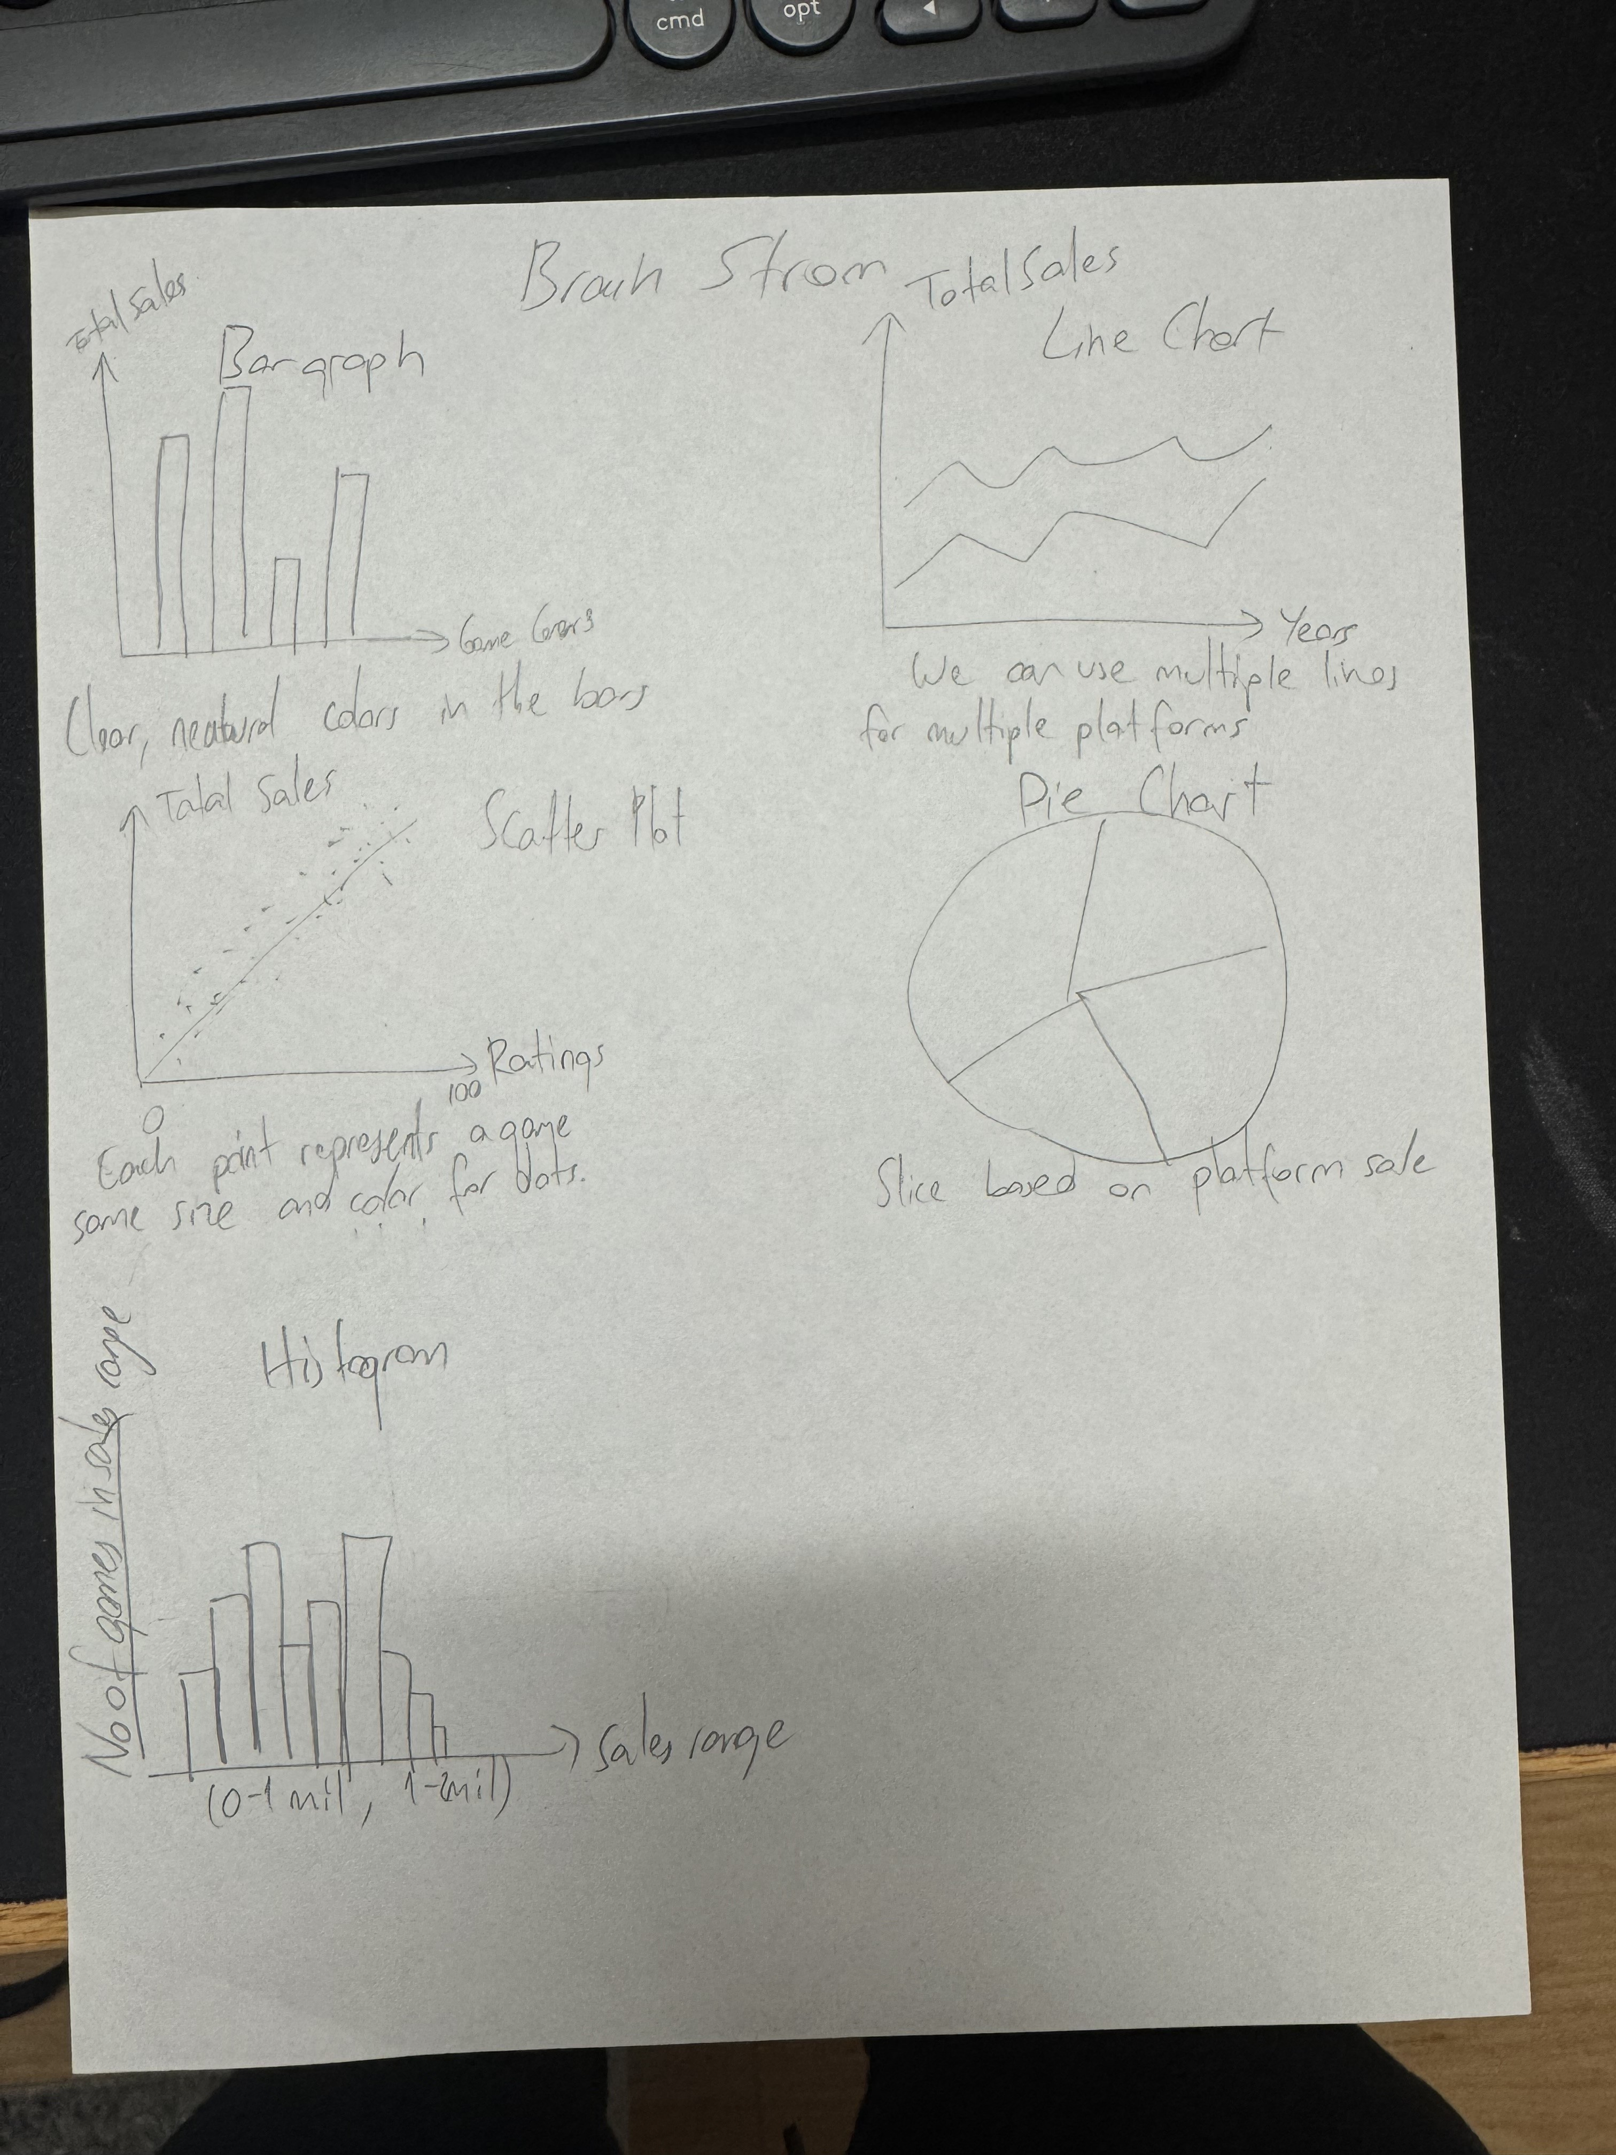

We used this sketch as a brainstorming tool. We came up with 5 different types of data visualization. This brainstorming tool consists of basic bar graphs, pie charts, and scatter plots etc. We wanted to see our options and got some feedback from “clients”.

Sheet 2:

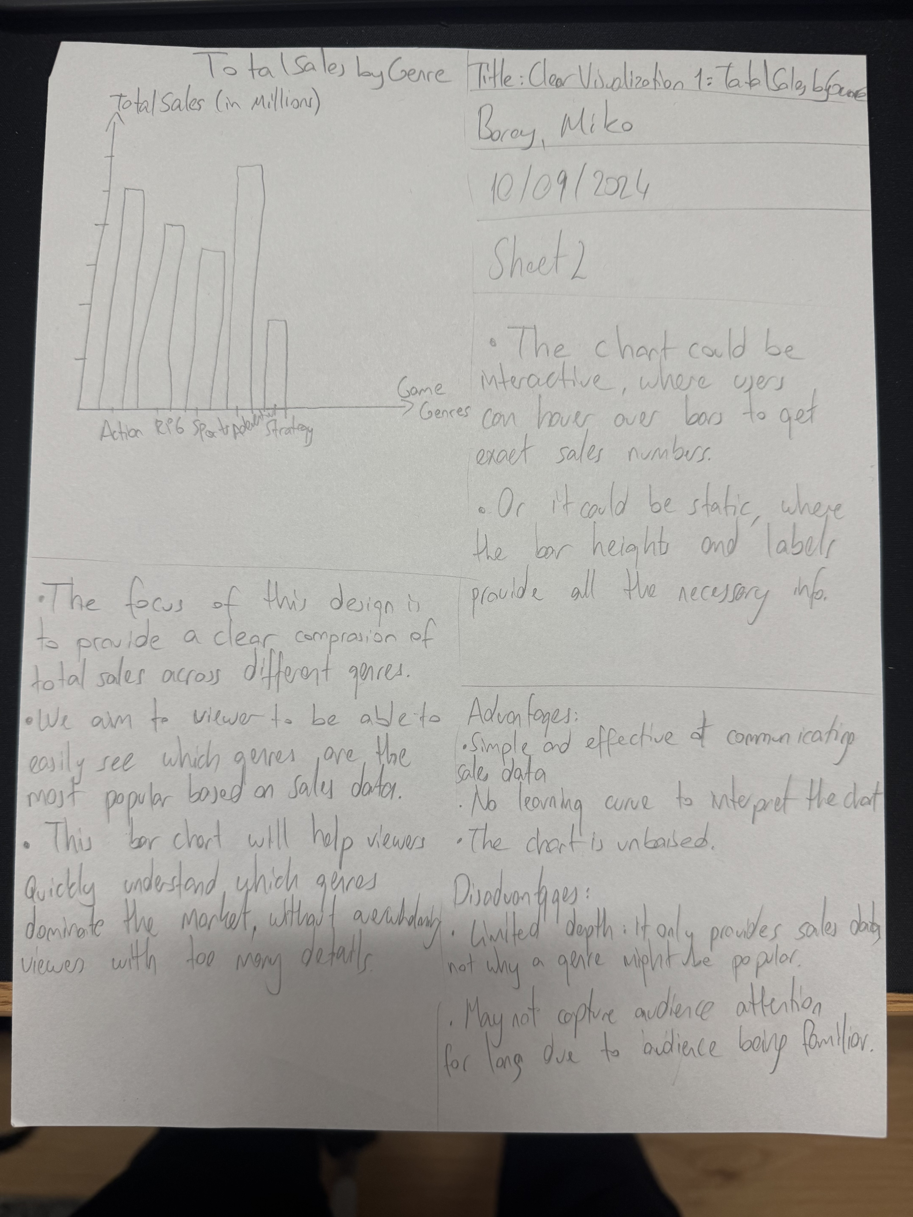

In this sheet, we wanted to see the interaction between total sales and type genres. This sheet tells us how different genres perform in sales. It is a basic bar graph which is easy to read and understand.

Sheet 3:

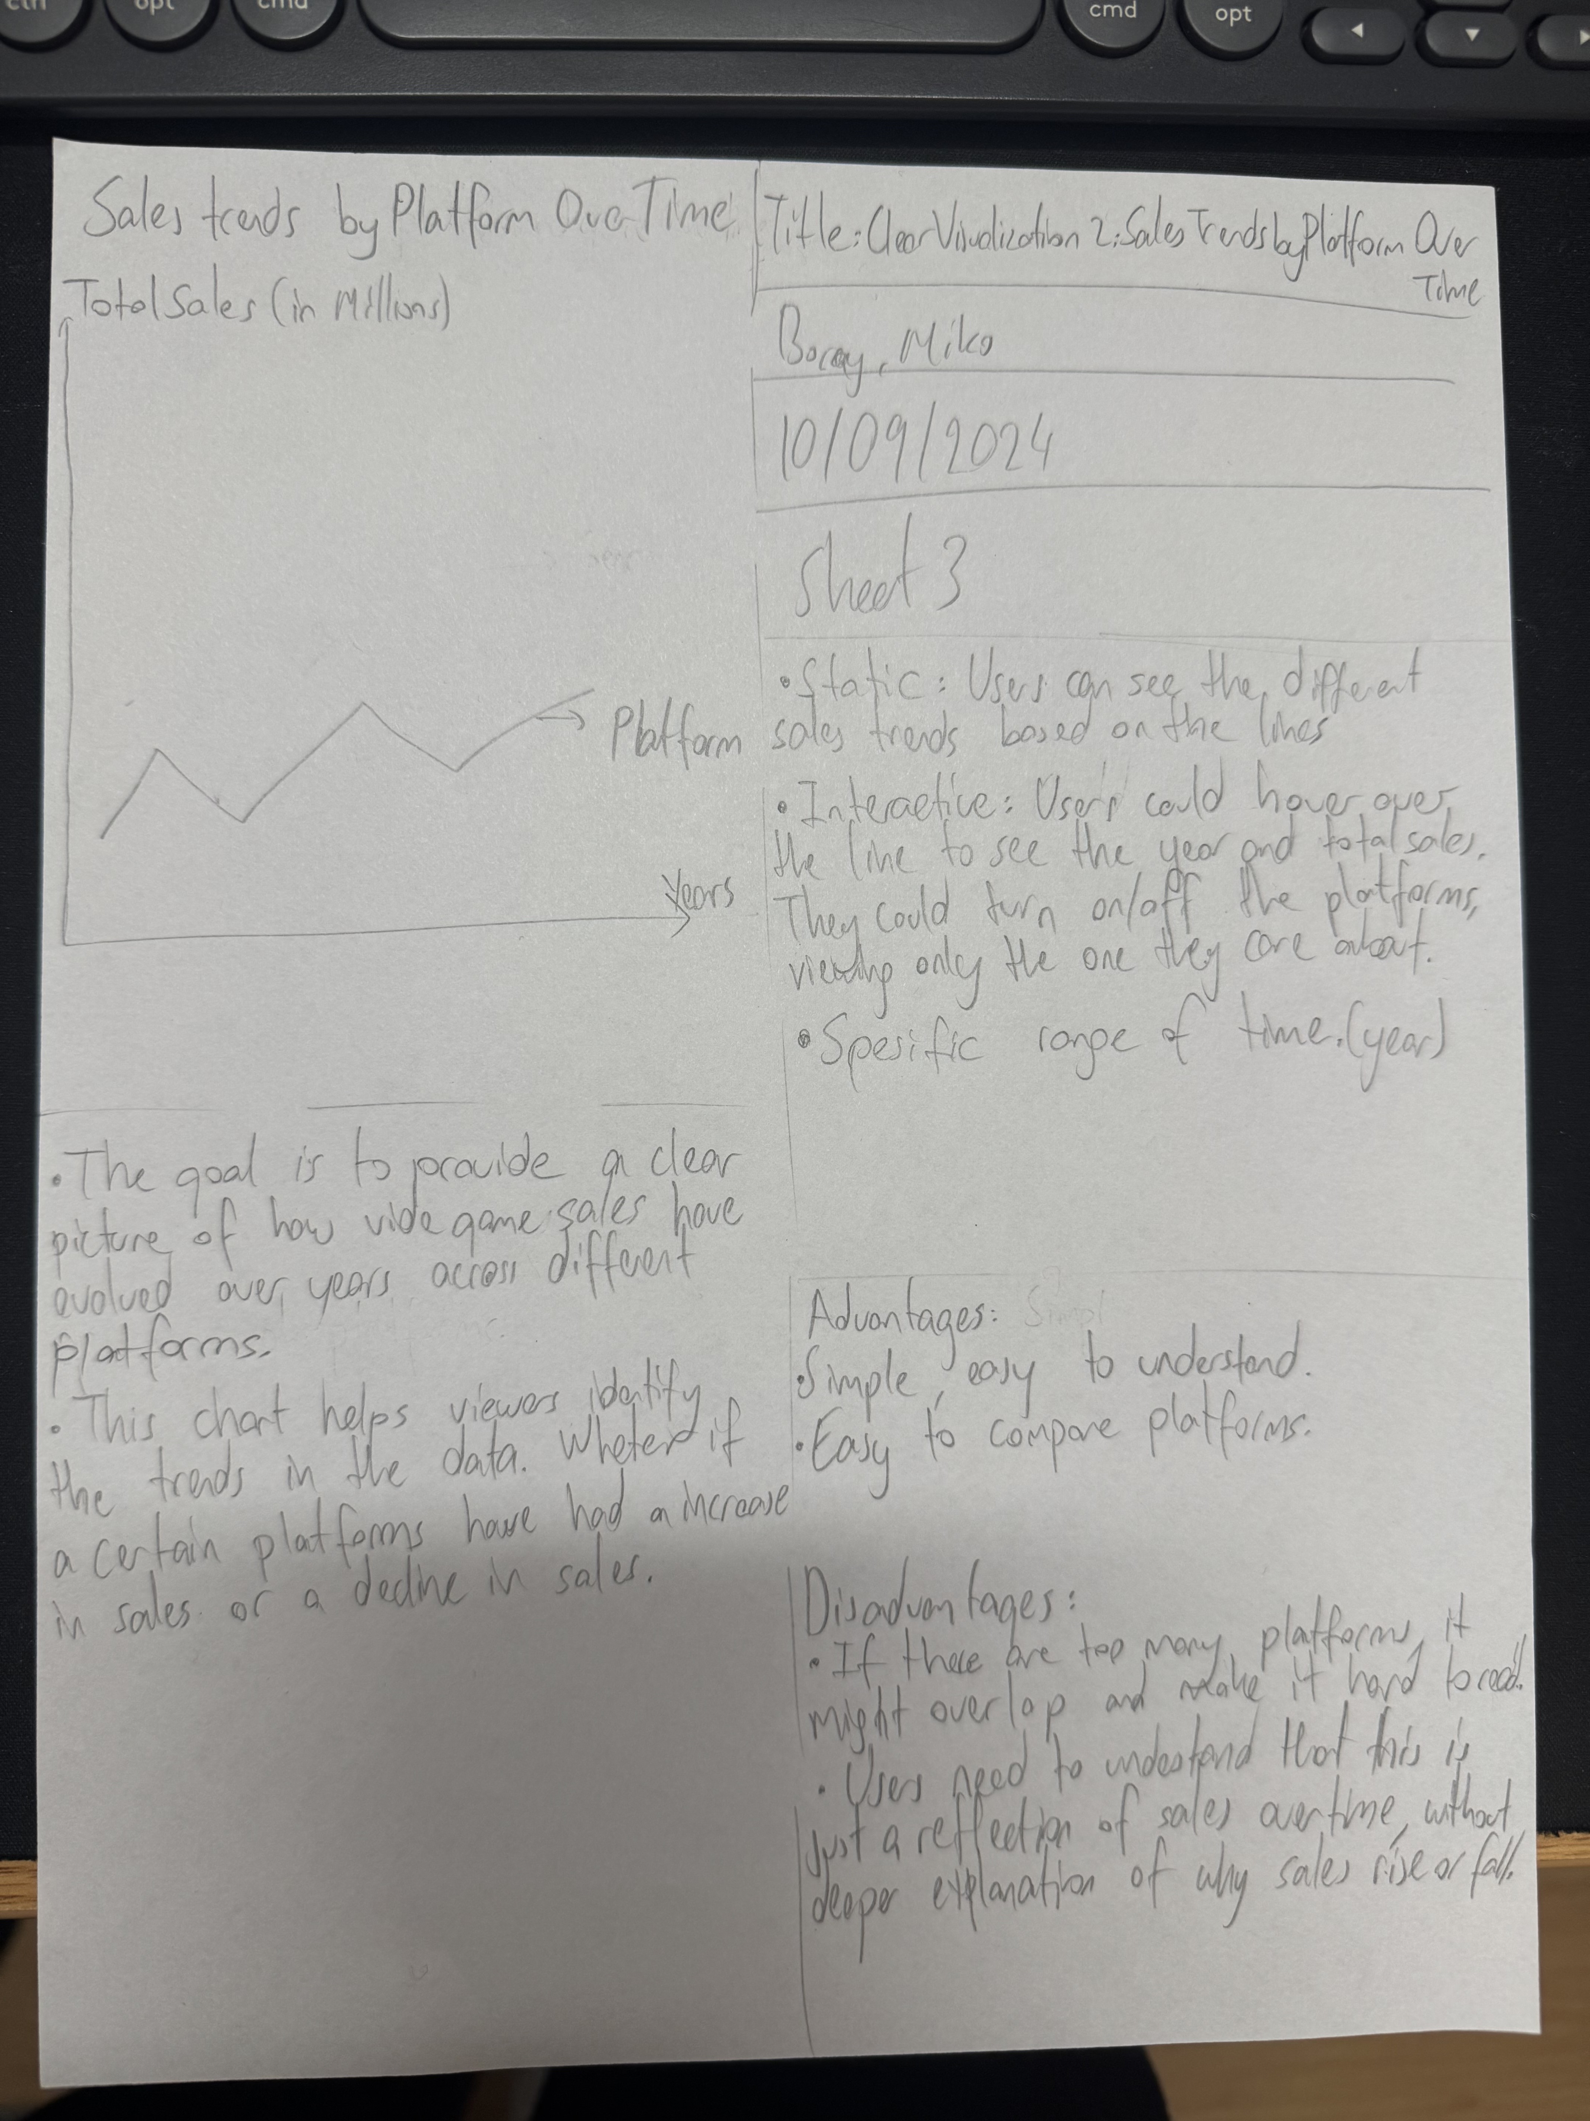

This sketch is a line chart. In this sketch, we wanted to see how well each game platform performed over the years. The performance is measured by the total sales in millions of Dollars.

Sheet 4:

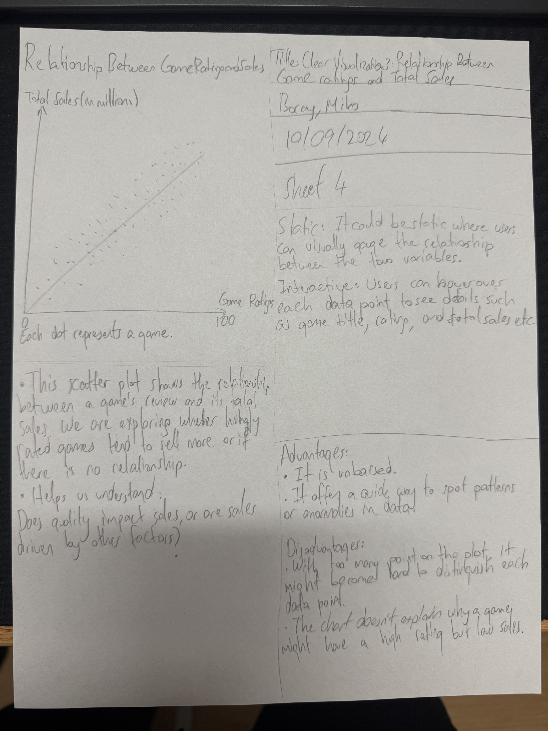

With this sketch we wanted to see the relationship between the game ratings and the total sales in millions of Dolars. We wanted to see if the games with higher ratings made more money or not.

Realization Design:

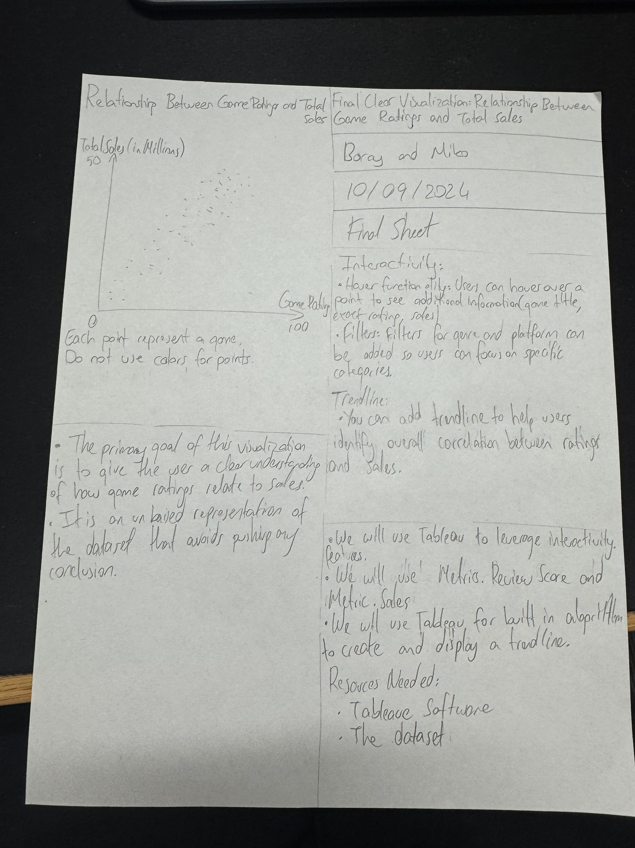

As our final sketch, we decided to work with the scatter plot. In the scatter plot we used game ratings and total sales as columns and rows to see the relationship between the profit of a video game and whether it depended on game ratings. But we realized static scatter plot wasn’t enough, so we added filters and highlighters to emphasize each video game. Also, we added a trendline to show the correlation between ratings and sales.

**Persuasive Storytelling Sketches:**

Brainstorm:

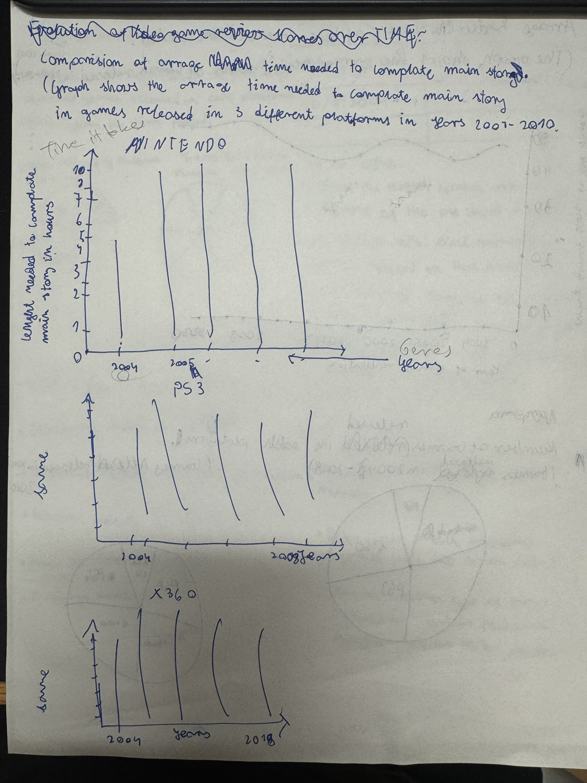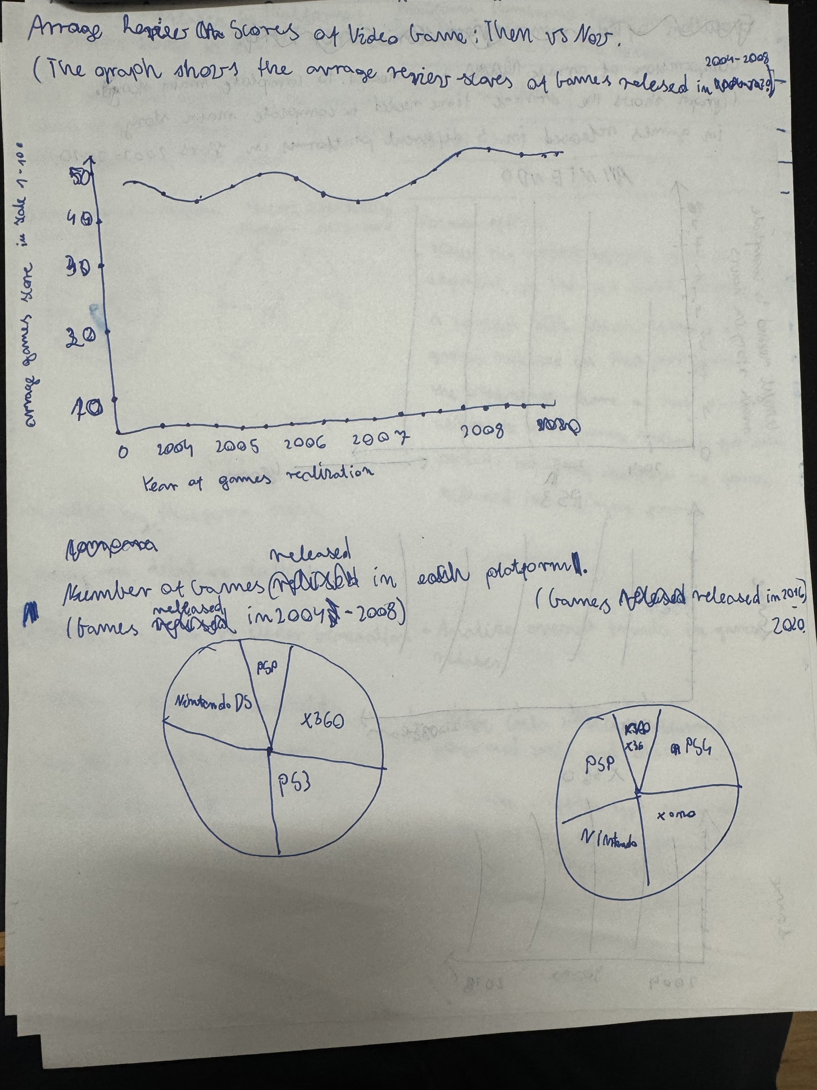

On our brainstorm there are several different visualization ideas that we initially came up with. There are visualization ideas like: Average scores of video game, number of games released in each platform, comparison of average time needed to complete main story.

Sheet 2:

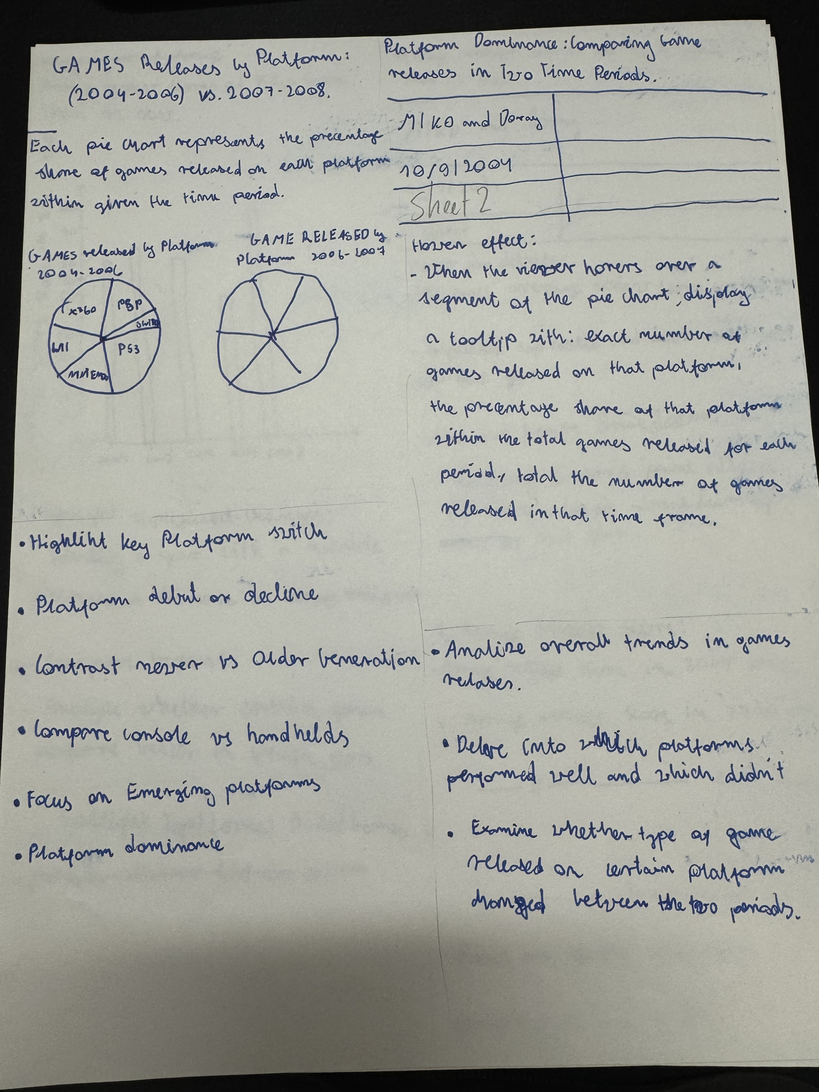

The second sheet contains platform dominance: comparing releases in two time periods. The layout window contains two pie charts that compare games released in two time periods on different platforms. In the focus window, we have placed information such as platform debut or compare console vs handhelds. In focus hover effect has been explained. Analysis of overall trends in games relation or examination of what type of game has changed in popularity over the years have been placed in our discussion window.

Sheet 3:

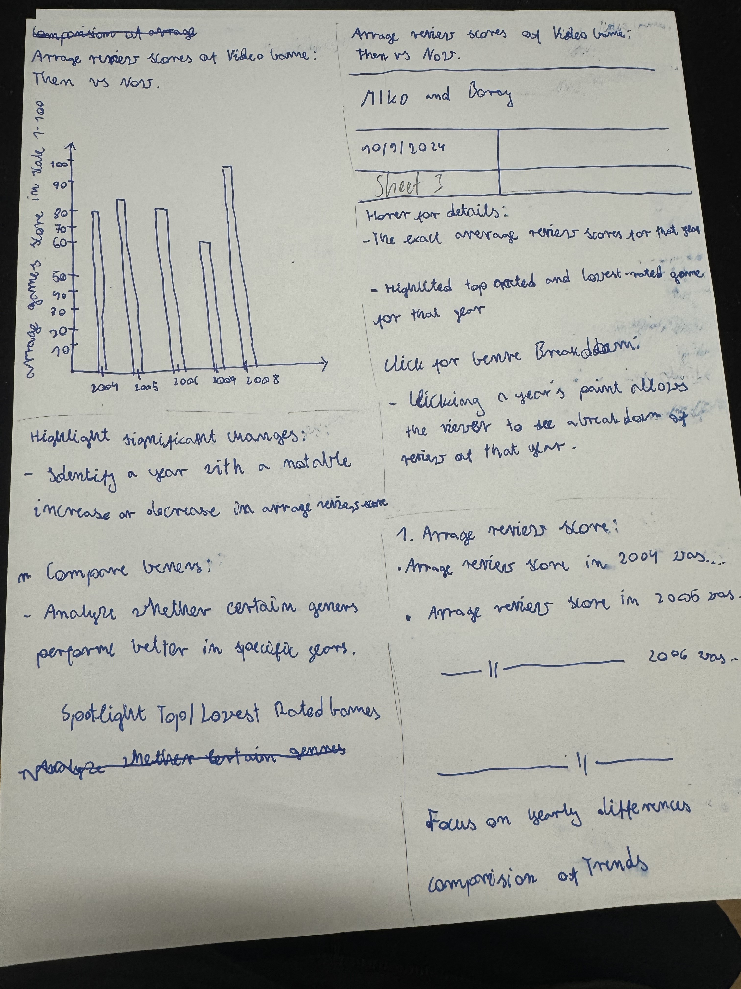

On this sheet are presented Average review scores of video games between 2004 - 2008. Layout presents a graph that shows how games were rated on average in each year. In the focus section we can put information such as highlight significant changes, compare genres, spotlight top/lowest rated games. In the details section there are such things as hover for details, click for genre breakdown. Things such as average review score in each year or trend comparison remain for discussion. 

Sheet 4:

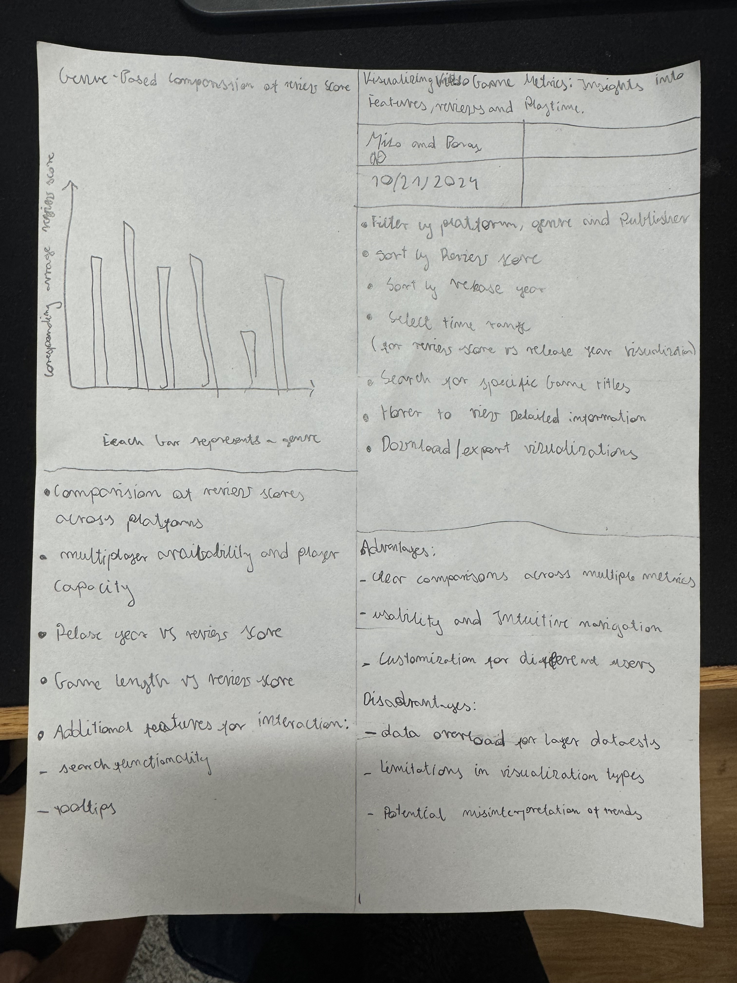

On this sheet we have placed visualizing video games metrics: Insights into features, reviews and play time. We have presented such things as a graph comparing genre with average review score. In addition, we can find here such things as relation years vs review score, learn how to perform some operations such as sorting or discussion fields such as clear comparisons across multiple metrics.

Realization Design:

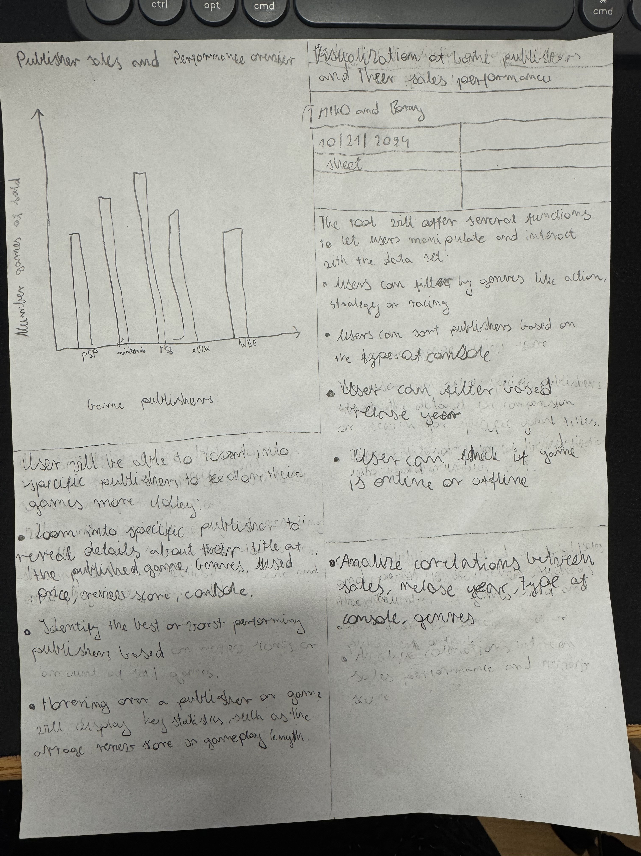

Our main Realization Design presents our final project that we decided to place here, namely visualization of game publishers and their sales performance. In the layout, a graph was presented that compares different game publishers and the number of games released in each period. In the zoom frame, we showed what happens when the user zooms into specific publishers to explore their games more. In the operations frame, we described a tool that offers several functions to let users manipulate and interact with the data set. In the last frame, an analysis of correlations between sales, relation year, type of console, genres were presented.